Dog Ate My Homework
Submitted by The Librarian on Thu, 06/24/2010 - 21:17
Author:
Qwerty
This page contains three parts. The first part, just call this General Elder Scrolls Weaseling, is devoted to recording the history of creative weaseling on the part of out favourite bunch of game developers, the inimitable Bethesda Softworks. In their long history, they've developed, as a collective, a well-honed talent for explaining away their own past shortcomings and coming up with plausible explanations for their own flops. Some of these lines are widely known; some are being published for the first time.
The second part is a memorable sub-section we called Daggerfacts. Due to some peculiar circumstances, Daggerfall never became the game it was initially meant to be. Bluntly speaking, it was rushed to the market just to meet the deadline. Because of that, many features were incomplete or plainly omitted, and some interesting inconsistencies surfaced.
This Daggerfacts sub-section is devoted to random little Daggerfall-related facts many might not know. There used to be a site on the 'Net, it was called "The Secret Scrolls" which was devoted to listing these. That site is down since quite a while ago, and its webmaster - Bo Gotthardt-Petersen - must have changed his e-mail address. This section will somewhat duplicate his work. By the way, I (Qwerty) used to contribute to The Secret Scrolls. But it was a while back.
Some of the facts in here were actual gameplay experiences of mine (Qwerty) or of my fellow fans. Some were provided by the fine folks who are (or used to be) employed by Bethesda Softworks. Of these, the one who deserves the fattest credit is Ted Peterson (later referred to as "Tedders", because that's how he likes to be referred to as on the 'Net), lead designer of Daggerfall, whom Julian LeFay was a sidekick of.
The third part, called Morrowind Easter Eggs, is a large list of easter eggs from Morrowind which were mostly collected by Sinder Velvin, the exceptions being "The Mystery of N'Gasta..." and "Fishy Sticks”.
Necessary disclaimer:
information below might spoil some of your gaming fun by providing plot-related information that the player's char is supposed to discover as the game goes.
- General Elder Scrolls Weaseling
- Daggerfacts
- Morrowind Easter Eggs

General Elder Scrolls Weaseling
Submitted by Proweler on Mon, 07/05/2010 - 10:34
Author:
Qwerty

Why are there no horses in Morrowind?
For two reasons. First, Dark Elves like them as a foodstuff. Second, native grasses of Morrowind give horses a bad, and often terminal, case of tummy ache.
Source: Ken Rolston in one of his pre-Morrowind online interviews. Reproduced from memory. If anyone has the original text, please let site staff know.
* * *

Why are all Dark Elves so skinny? Where are fat Dunmer?
For the very same reason. Since there are no horses in Morrowind, the locals have to run to get to places. As a result, they get a lot of exercise and stay slim.
Source: Mark "BlueDev" Nelson, in a personal conversation.
* * *

Why are there no dragons in Morrowind?
Skylamps. They would actually be, moretheless, the Cliffracers. In short, the cliffracers came to Vvardenfell and pushed the dragons out. At one time, dragons flourished in Vvardenfell, being drawn to the comfort of the warmth in Red Mountain. The cliffracers grew in numbers (just as they appear to do in MW, since they seem to pop up behind you every 8 seconds). At first, this was not a problem for dragons. They were actually pretty good eating. But, just as a praying mantis is a big king of bugs, 1000 ants can easily take him. Thus, the dragons found themselves in a losing battle over the territory. Food sources and dwellings became overrun and the dragons simply packed their bags and moved on. The cliffracers plagued Red Mountain and in the end, drove the dragons out.
Some say the dragons moved on closer to Cyrodil, where they gained shelter and security from the Empire, along with dragons from other parts of Tamriel. Dragons are very sacred to the Empire, and as long as the Empire protects the dragons, the dragons MUST offer services to the Empire, such as aiding and protecting the Imperial forces in war (Redguard, the fight for Stros M'kai).
Just a little "in the know" for those who are curious about dragons. They DO exist, just not everywhere. Even in Cyrodil, where the majority of dragons may be, they are scarcely seen. Could it be they can shapeshift and use human form?
Source: Posted on the Official Forums by WormGod.
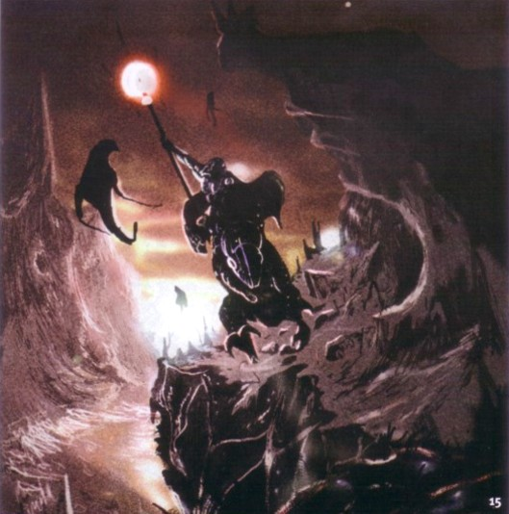
Skylamps along Dagoth-Ur

* * *

"Daikatana" is not a correct Japanese word.
Daikatana is an Akaviri weapon. "Daikatana" is a word from the Akaviri language, not from Japanese. It sounds Japansese by pure coincidence.
Source: discussion at the official Morrowind forum.
For this one, some explanation is in order.
Linguistically speaking, the word "Daikatana" is an abomination. It consists of two Japanese (CJK, to be precise) characters - "big" and "sword". Each of them has two phonetic representations, two ways of reading - "on" and "kun", like this:
Character | On | Kun
Big | dai | ô
Sword | tô | katana
Circumflex is used here to denote long vowels.
Most of the time, when a composite word is formed, it's made up of on's. In some cases, it's made up of kun's. But combining on and kun in one word is, basically, wrong. There are some exceptions to the rule, but this isn't one of them. "Daitô" is fine, "ôkatana" is permissible, but "daikatana" isn't.
* * *

Why are Dwemer called "Dwarves"?
Long time ago, Dwemer met and made friends with a race of intelligent Giants. The Giants would call their Elven neighbours "Dwarves". Eventually, others adopted this name for the Dwemer as well.
I don't remember who made this up. Please come forth so that I can give credit.
* * *

In Daggerfall, sulfur is red.
Source: Ted "Tedders" Peterson, in an e-mail, wrote the following:
I know that pure sulfur isn't red, but if you check out the article I attached, the red stuff (...) is considered sulfur as it consists primarily of the stuff with, as you say, some chemical impurities. I don't think it necessarily follows that the purity of the ingredients is what's important in alchemy, like the Potionmaker. It may be that the additional chemicals in red sulfur is what gives it its unique magical properties, just as the rarity of certain imperfections in diamonds that make them blue or yellow give them additional value. Incidentally, if at any point you want me to 'fess up that it was a simple art mistake, let me know. It's just more fun to argue the unarguable.
* * *

Why is the land of Khajiiti called "Elsweyr"? Who would agree to live "Elsewhere"?
Elsweyr did not exist as a separate polity until the kingdoms of Anequina and Pellitine made an alliance. While doing so, they recalled an old Khajiiti proverb that went along the lines of "perfect society is always elsewhere". In their optimism about the new alliance, they tried to bring forth good luck by appealing to that proverb.
Source: Ted Peterson, in an e-mail
* * *

Why don't clothes in Morrowind have a health rating?
Clothes don't have a Health rating like armor and weapons do. Why? Well...
The tailors of Morrowind, due to the unusually harsh environments, have been forced to use unusual materials for their clothing needs. While they first experimented with a wool woven from the fur of the waste rat, this proved to be unpopular. The material, while fairly durable, stank to high heaven when wet. Additionally, the scent tended to attract other waste rats, making the garments especially unsuitable for children and the elderly.
After many years of searching the continent for a suitable material (now referred to as the Great Chafing), the intrepid craftsmen discovered the silk of the blight moth. Though not truly a blighted creature, it's coloration resembled the ash grey left by the mysterious disease infecting the land. The silk, it turned out, was incredibly resilient, pliable, and easy to work with. It also readily accepted magicks, making it a popular material for enchanters. After years of experimentation, tailors perfected the weaving of this delicate silk into thread.
Today, you'll find almost all of the clothing of Morrowind is made of this super strong blight moth silk, as it never degrades, is highly resistant to damage from the elements, and even seems to repair itself from damage. Lo, the wonders of Morrowind.
Source: Posted on the official forums by Mark "BlueDev" Nelson
* * *

Shady Grove? What Shady Grove?
Remember the introductory movie of TESA: Redguard? Specifically, the part where the camera zooms in slowly on the map of the West Tamriel? In the middle of Hammerfell, there's a place name "Shady Grove". On this screenshot it's pretty prominent:
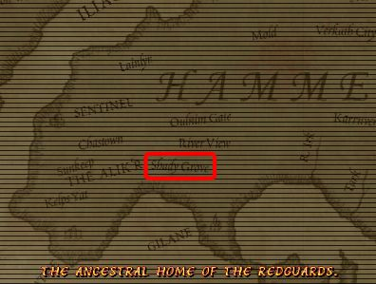
Albeit it sounds innocently enough, it's in fact an easter egg. "Shady Grove" is the name of a street and of a metro station not far from Bethesda's office in Rockville, MD.
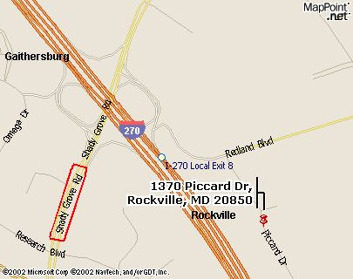
The red pushpin on the map above denotes the location of the Bethesda HQ, as found at their own site.
Source: Qwerty's creative observation
* * *

Inconsistency with the Shadowkey map
Well the thing with map making is that the maps are done from the point of view of the cartographer. A resident of Tamriel may not have access to a flight spell to gauge accuracy and certainly would not have access to a satellite photo. So is it really so far fetched to believe that a cartography from that area of Hammerfell would draw his map with inaccuracies? It seems obvious the maps highest function was to point out the most important areas that a traveller to that area would need to take note of.
Source: Developer Michael Wagner AKA Sentinel, on the forums
* * *

Mariah on fire
Mariah is a gardener in Stros M'Kai City; she's a Redguard, like most natives. Also, she has the most annoying voice in the whole game. Ken Rolston and Todd Howard have once apologized for Mariah, on the record. You only need her once for the storyline to proceed.
Here are samples of her "sweet" voice:
[swf file="dogate_mariah1.mp3"]
[swf file="dogate_mariah2.mp3"]
[swf file="dogate_mariah3.mp3"]
[swf file="dogate_mariah4.mp3"]
There's a reference to her in Morrowind, which you can find here. And you can set her on fire with a torch; that's a Redguard easter egg.
Source: Qwerty
* * *

Soul Cairn Tombstones
On Battlespire's third level, the Soul Cairn, there is a cemetery with tombstones on which rather silly things are sometimes written.
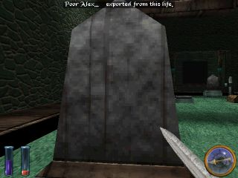
Here are all the inscriptions:
Sacred honor, loyal love, eternal service.
The Soul Serves that Never Dies The Saint that Saved Us All
Genius and Power passes. Peace and Constance triumphs.
Shift my oars and wherry, For I shall pass over In the company of friends and lovers.
Thus do I cheat the worms of their unjust plunder.
I was, and wasn't, and was again forever.
Neither prophet nor profit, we pass empty-handed into the light.
In these worlds beyond the sun no darkness hides the distant shore.
We have done, and do, and will do. The gentle flowers of the sun doth triumph o'er the grave.
Poor Alex... Exported from this life.
Quadrille Pig gave up the ghost.
Source: Sinder Velvin
* * *

The Mock Turtle
The Mock Turtle is a reference to the story from Alice's Adventures in Wonderland by Lewis Carroll. In Battlespire's first level, there is a very interesting Mock Turtle in a secret room which can be reached by throwing yourself from the Star Galley bridge onto the walkway below and then following the walkway to a teleporter. Here's a shot of the walkway as seen from above.
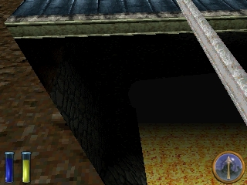
When you activate the Mock Turtle, this is the message that you get:
The Mock Turtle introduces himself as a member of the rare species of Great Turtle from which is made the famous Mock Turtle Soup, the Soup of Kings. "Sit down and don't say a word until I've finished. Once," said the Mock Turtle with a deep sigh, "I was a real Turtle." The Mock Turtle relates a tragic and lengthy tale about going to school in the sea, and about his studies in the obscure disciplines of the Quadriva Arithmetia - Ambition, Distraction, Uglification, and Derision -- and the courses of instruction in Mystery, ancient and modern, with Seaography, Drawling, Stretching, Fainting in Coils, Laughing and Grief. At last, when it becomes clear that his story has no point, you become restless. "Oh dear," said the Mock Turtle. "I'm afraid I've bored you. You've been so kind to listen to the maunderings of an ancient reptile... Please say my name backwards where it will do the most good, accept as a token of my gratitude a product of my researches in the field of Speculative Ontology."
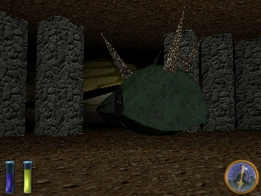
Source: Sinder Velvin

Daggerfacts
Submitted by Proweler on Mon, 07/05/2010 - 10:36
Author:
Qwerty
Remember Gortwog, the Orc-lord of Orsinium? His full name is Gortwog gro-Nagorm. It's the Orcish way of providing a patronymic (father's name); Nagorm was his pops. If Gortwog had a sister, she would've been gra-Nagorm.
* * *
Did you notice that all months are 30 days long in Daggerfall? This makes Tamrielic (Nirn's) year 360 days long.
Xan's note: The calendar in Arena's manual states differently. Morning Star has 31 days, Sun's Dawn has 28 days, First Seed has 31 days, Rain's Hand has 30 days, Second Seed has 31 days, Mid Year has 30 days, Sun's Height has 31 days, Last Seed has 31 days, Hearthfire has 30 days, Forstfall has 31 days, Sun's Dusk has 30 days, and finally Evening Star has 31 days. Total: 365 days. Perhaps due to the deadline, the Daggerfall calendar system was not fixed. Even Morrowind has problem with its calendar system. The year in Morrowind starts from Sun's Down not Morning Star as it should be. And it's never fixed by the patches. See this for more information about the calendar issue.
* * *
There's a series of 10 books called "The Real Barenziah" (available here). In the game, all books are called "The Real Barenziah, Part NN" except for Part VIII, which is "The True Barenziah". Scribe's mistake?
* * *
A similar snafu plagues the series about King Edward (available here). All parts are numbered with Latin numbers (I, III, IV, V, VI...) except for the second part, which is numbered with an Arabic number (2).
* * *
Many deities, heroes and Daedra Princes in Daggerfall were named after actual people, members of development and testing teams at Bethesda. With some of these, it can be figured out from the credits in the manual.
- Julianos was named after Julian LeFay himself;
- Stendarr - Daniel Starr (Dan Starr -> StenDarr, pretty obvious);
- Arkay - R. K. Deutsch;
- Mara - Marilyn Wasserman (confirmed, and she is the author of "The Real Barenziah" and "King Edward");
- Dibella - Mary Jo DiBella;
- Akatosh - this one's complicated. There was this beta-tester named Lawrence Szydlowski, which is obviously not a very good name for a generic fantasy setting of Daggerfall. His online nickname was Smaug, and it was not very good either, since Smaug is widely known. His sign-off, though, was Larry, "also known as the Old Smaug himself." That spells out A.K.A.T.O.S.H., so Akatosh became the name of the dragon god of time.
- Zenithar was based on a tester named Stephen Zepp.
- Kynareth - surprisingly enough, this name was not based on anyone's. Kynareth, however, was mentioned in TES: Arena. She was the spirit behind the artifact called Lord's Mail, and the dungeon where the Mail was to be found was Kynareth's crypt.
- Sheogorath, the Daedra of Madness, was the the alter ego or Tedders himself. Ted -> Theodore -> Sheogorath. We have a section, dedicated for him.
- Jone and Jode, the moons on Tamriel (Nirn) are testers Judy Weller and Joan McKeown. Joan and Judy = Jone and Jode.

* * *
In the middle of Daggerfall's TEXT.RSC file (it's the one that contains, among other things, all generic dialog messages) there is a very long piece of what looks like extremely bad poetry. It cannot be encountered anywhere in the game. Tedders told me that it was a remnant of another never implemented feature - bard songs. The idea was that when the PC went into the tavern, the bard would be singing a tune, composed of several distinct rhyme schemes -- maybe ABABABCC or something -- with phrases grabbed to rhyme.
See the whole list of poetic lines here. But be warned, it's a long read.
* * *

Morrowind Easter Eggs
Submitted by Proweler on Mon, 07/05/2010 - 10:36
- TES3:Morrowind
Author:
Sinder Velvin
Jump to the easter egg of your choice: <Arlowe, Kyanka And The Banhammer> <Best Designers In Morrowind> <Boat Ack> <Bottle In The Sea of Ghosts> <Castings For The Voice of Azura> <Charles The Plant> <Creeper> <Dagoth Brandy Toast> <Eltonbrand> <Eye of Argonia> <Fat Lute> <Fishy Stick> <Funny Sound> <Hidden Stash Near Thirsk> <Huge Creatures> <Indiana Jones> <Joshur The Bard> <Kagmeowti> <Lustidrike> <M'Aiq The Liar> <Muffin> <Naked Barbarians In Morrowind> <Orcish Khajiit> <Peke Utchoo> <Pool of Forgetfulness> <Pop Je> <Scourge> <Talking Mudcrab Merchant> <Tarhiel> <Testing Morrowind> <The Good, The Bad And The Ring> <The Mystery of N'Gasta! Kvata! Kvakis!> <The Museum of The Imperial> <The Natural> <Use The Force> <Wormgod, Master of All Pipes>

Arlowe, Kyanka And The Banhammer
Once upon a time there was (and there still is) a site called Something Awful, hosted by Rich "Lowtax" Kyanka. In the past, Lowtax was also called R-Lo on the Something Awful Forums, and the Banhammer was called upon when somebody didn't read the rules and made abusive posts, annoying people.
Anyway, since Hayt is apparently a member on the Forums there, there are jokes about Something Awful in Morrowind. First of all, there's the body of someone named Arlowe (notice the resemblance to R-Lo) on an island to the west of Tel Aruhn, next to an Ashlander tent - the coordinates are Azura's Coast 13, 5. If you search Arlowe's corpse, you will find the famous Banhammer.
Second of all, in Tribunal, if you acquire the Mace of Slurring and then go to the Mournhold Museum of Artifacts and ask the curator about the artifact, she will say the following:
"Yes, it's a rather...odd piece. From what I've gathered, it was crafted near the end of the Second Age by Kyanka, a slightly deranged Altmer weaponsmith and enchanter. He had a rather warped sense of humor, and apparently delighted at the thought of reducing opponents to a gibbering mess before crushing them to death. The mace has, admittedly, seen little use."
Thanks to Zephyr for the details.
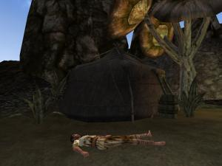

Best Designers In Morrowind
After looking everywhere in Vvardenfell, Mournhold and Solstheim, I've reached the conclusion that the Ash Slaves are the best designers that can be found in Morrowind. I took a short interview of one of them and... What, don't you know that you can talk to Dagoth Ur's minions? Of course, you must be undetected first, but you can talk to them like you talk to any NPCs. Anyway, here's what an Ash Slave told me:
"The chairs. The tables. All confused. We hear the words, and must speak them. We take them, and arrange them, but still, they will not be quiet."
Ah, yes, Dagoth Ur wanted to keep up with the latest trends and that's why he made his minions re-arrange the furniture. Or perhaps he's into Feng Shui? Heh... Anyway, while I was visiting one of Dagoth Ur's citadels, Kogoruhn, I asked an Ash Slave to tell me what was wrong with the room he was working at. These were his words:
"Everything is wrong. This is not straight. This is too high. This is in my way. We must put them right."
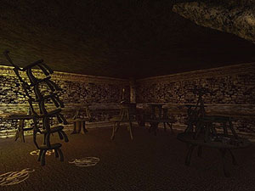
Fascinating, isn't it?

Boat Ack
In the book "No-h's picture book of wood" it says that "Boat Ack" was scrawled in a vandalistic manner all over the page. In his teen years, Kurt Cobain was caught by the police vandalizing a boat with the aforementioned "Boat Ack". Apparently, this little detail appears in C. R. Cross, Heavier than Heaven: A Biography of Kurt Cobain(2002).
Credit goes to the forum member named Namira who discovered this easter egg eight years after the game was released.

Bottle In The Sea of Ghosts
To the northeast of Dagon Fel, in the Sea of Ghosts, you can find a submerged bottle near some kollops. It contains a note that you can find here. If you want to see this bottle with your own eyes, type the following in the console:
player->coe 9, 23
You'll find yourself underwater, near the bottle.
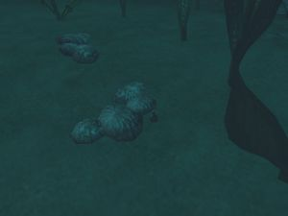

Castings For The Voice of Azura
After a long, long time in which we have been ignorant, we now know the truth. Before I say anything else, check out these two files.
Intro1aDDB.mp3
Intro1aJon.mp3
The first file can be found in Morrowind\Data Files\Sound\Vo\w\m.
The second file can be found in Morrowind\Data Files\Sound\Vo\a\m\.
Shocking. What should we think of Azura after hearing these? Could the rumors about her being a cross between a Daedra Prince, an Argonian and a Wood Elf be true? Well, I don't think so. I think that at the castings for the male Argonian and the male Wood Elf voices, two voice actors were asked to read the introductory speech, so the developers could see if their voices were suitable. And, somehow, these two files found their way in Morrowind's data files. Thanks to Stalker for telling us about this easter egg.

Charles the Plant
I'm quite sure that you know Jobasha, the librarian in Vvardenfell, Vivec City. Well, did you know that he has a very interesting plant called Charles? Yes, that's right. And, if you want to, you can take its "Meteor Slime" and use it to make potions. Just make sure nobody sees you when you take it.
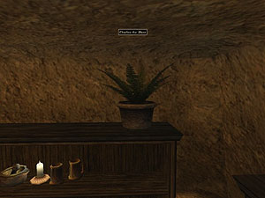

Creeper
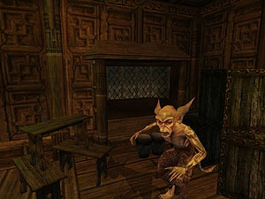

Creeper is so well-known that it's almost a mistake to say that he is an easter egg, even though he was meant to be one. Anyway, for those of you who still don't know him, I should say that he is a very interesting Scamp living in Vvardenfell, Caldera, in the Ghorak Manor. As you might already know, Scamps can communicate, but they usually don't make any sense. But that didn't stop Creeper from becoming a wealthy merchant, since, as you might have found out by yourself, merchants are usually senseless. In fact, because he gets so much business, Creeper can afford to sell items at their real value, having no need or desire to artificially increase the price of his wares according to market trends. How senseless is that?! Now, Creeper's words might not be logical, but they're probably worth recording. Here's what he said the first time I met him:
"I'm creeping!"
Very interesting, isn't it? Next, he said the following:
"Hello Caldera!!! I'm here all week!"
Don't let him fool you: he never leaves the spot you find him in. He also said:
"Help me out. I need the money."
Scholars could argue why he needs even more money than he already has, since he always seems to have at least 5000 gold pieces in his... Er... Pockets? But let's not argue the unarguable, yes? Here's what Creeper said next:
"C'mon... Help a scamp out. You gotta need something. I've got booze..."
He did, indeed, have a lot of booze. In fact, he even had some rare dagoth brandy which I bought from him, but I should warn you that it wasn't too good... So don't try it yourself. Next, the Scamp said the following:
"Don't want to work. Just want to bang on my drum. What's a scamp gotta do?"
This seems like pure nonesense to the uninitiated (meaning me), but Love_From_Above has informed us that there is a song by Todd Rundgren called "Bang The Drum All Day" which goes like this:
I don't wanna work
I just wanna bang on the drum all day
I don't wanna play
I just wanna bang on the drum all day
Interesting. But what, exactly, should a scamp do? Terrorize the countryside? Probably. Anyway, I left Creeper alone with his gold and the half-dozen orcs he lives with, after which I started roaming the West Gash. But that, my friends, is a tale for another time.
Also, here's what developer Mark Nelson, AKA BlueDev, said about this easter egg (and about easter eggs in general):
It would be great to be able to include references to all the great fans of our games. It would also be great to include references to all our friends, family, etc. Unfortunately, there just isn't enough time to cover everyone. We do try to sneak them in when we can, though. Heck, Creeper is based on my best friend (who, at the time, was an unemployed drummer [and part-time drunkard]). So, we do what we can. No promises, though.
By the way, I figure you might like an explanation as to why Creeper and the Talking Mudcrab Merchant sell things at their base values. Well, bartering was made to only be done with NPCs of the playable races (Breton, Dark Elf, Hight Elf, etc.), and you were not meant to be able to barter with any creatures. See, when determining the price of items in "normal" bartering (with NPCs of playable races), things such as NPC disposition, NPC faction, PC faction, PC rank and PC mercantile skill are taken into consideration. Well, creature NPCs don't have a disposition or a faction, and they are not affected by the PC's mercantile and speechcraft skills. The logical result is that creature NPCs only sell things at their base values. If, however, you happen to stumble across an item that you cannot buy or sell to a creature NPC at its base value, you should know that the item is probably in a state of disrepair, thus its reduced cost.

Dagoth Brandy Toast
Ah, more about Dagoth Ur's minions. This time, we're going to record the words of Dagoth Endus, the Ash Vampire living in the Sixth House citadel of Endusal. Here's what he says when you greet him:
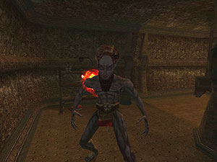

"I greet you, {Nerevarine's name}. Or Nerevar. Or whoever you are. I'm Dagoth Endus, brother of Dagoth Ur, and lord of Citadel Endusal. Would you like a little ancient Dagoth brandy?"
If you ask him about dagoth brandy, he says the following:
"It is a rare nectar beyond compare, distilled ages before your ancestor's ancestors. And a fitting toast to our challenge. Would you like to sample it?"
If you disagree, here's what he says:
"No? Pity. But then, a pity to waste it on a coward like you. I'm done talking. I await you first blow, challenger."
If you agree, he says the following:
"Then I drink to your health. Bottoms up..."
If, after that, you ask him about dagoth brandy, he says:
"Whenever you're ready, then? You're the challenger, and I am your host. So honor demands that you deliver the first blow."
Needless to say, the Nerevarine killed Dagoth Endus after this short conversation. Now, what should we learn from this incident? Alcohol leads to death...

Eltonbrand
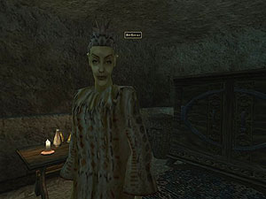
Ah, Eltonbrand- an exquisite sword and, from my opinion, the best sword in the Morrowind game. If you ask me, this is the most well-hidden easter egg in the game, and the chances that you will be able to get this sword in the game by accident are close to zero. I, for one, found out about this sword by carefully analyzing Sirilonwe's dialogue (she's a mage in Vivec City's Guild of Mages). But more about that later.
In order to get Eltonbrand, you must have Goldbrand in your inventory, be a vampire and have at least 11171 gold pieces. Must I refresh your memory as to what Goldbrand is? It's the one-handed long sword that you get as a reward for completing Daedra Prince Boethiah's quest. Now, as I was saying, you must talk to Sirilonwe and complete her first quest, which involves killing a rival of hers and bringing her a key in that rival's possesion. You must not have already killed that rival, since, if he's already dead, you won't be able to get Eltonbrand. So, when you return to Sirilonwe to claim your reward, you must have exactly 11171 gold pieces and Goldbrand in your inventory (just throw your extra gold on the floor) in order to get a very strange message besides Sirilonwe's normal dialogue. Here's Sirilonwe's normal dialogue:
"Excellent. Sometimes I wonder if it is not a good thing your kind exists. You may keep whatever else you found on his corpse. I'm sure that the fool had something of use to you. If you are still looking for something to do, I require some vampire dust for a spell I'm researching."
Now, below that dialogue, you'll get the following message:
"Go to Hell, Carolina!"
Basically, by completing Sirilonwe's quest the way I said (not having had killed Shashev, her rival, before she asked you), a script called "bluescript" starts. This script checks to see if the PC has Goldbrand and 11171 gold in his inventory and, if he does, Goldbrand is replaced by the much better Eltonbrand, whose object ID is "katana_bluebrand_unique".
But many questions remain. Why 11171 and not some other number? Why Eltonbrand? Why the part about Carolina? Alvirdimus did some research about this easter egg, which was later confirmed by Mark Nelson (AKA BlueDev), the one who put the easter egg in the game in the first place. First of all, 11171 is a reference to Mark Nelson's date of birth, the 1st of November 1971. Second of all, Mark went to Duke college, which had a basketball team by the name of "Duke Blue Devils", which is likely the reason why he chose the nickname BlueDev. Also, the NBA basketball player Elton Brand played on this team. And, about the Carolina part, it would appear that the North Carolina Tarheels are the Blue Devils' most hated rivals. Thanks, Alvirdimus.
More information about the Goldbrand sword can be found in the Artifacts of Elder Scrolls section.

Eye of Argonia
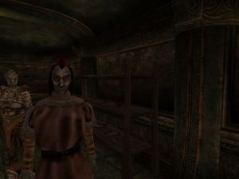
During this quest you are asked to make a journalist, Trels Varis, stop printing lies. Eventually, you find that journalist's hideout and he greets you the following way:

"What are you doing here? And may I suggest you make your answer very clear, because this office and what we do here is a well-kept-secret. And we wish to keep it a secret, even if it means that you do not leave here alive."
You can say one of the following things:
"You will stop printing lies about King Helseth."
"Excuse me. I'm just an honest working burglar, and I want no trouble."
"I'm looking for the Eye of Argonia."
"My mistake. I'll leave, and keep your secret. Honest."
To complete the quest you need to choose the first option. If you choose the second option, Trels Varis will say the following thing:
"I see. You've made a serious mistake. I don't approve of your trade -- but I understand that a desperate person -- or imprudently greedy person -- may turn his hand to crime without being truly evil. Very well. You may go. I'd like to preserve our secret office... But I won't kill you to do it. Just go... And keep your mouth shut."
If you choose the fourth option, he says the following:
"'Honest.' So you expect me to trust you? My experiences with trusting adventurers like you have been disappointing in the past. But... This time, you may go. I'd like to preserve our secret office... But I won't kill you to do it. Just go... And keep your mouth shut."
Now, if you choose the third option, here's what he'll say:
"Congratulations. You have produced an original and entertaining excuse. Completely unbelievable, of course, but none the worse for that. Never heard a believable excuse before, anyway. Very well. You may go. I'd like to preserve our secret office... But I won't kill you to do it. Oh, well. Since our offices are no longer secret, we'll have to relocate immediately. But don't touch anything here, and don't interfere with myself or my colleagues, or you will not leave here alive."
In case you didn't know, the game that was supposed to be the second Elder Scrolls Adventures game was called the Eye of Argonia. It was designed, but it was never developed, as Redguard had not been very succesful. So the developers decided to work on Morrowind. Thanks to Alvirdimus for telling us about this easter egg.

Fishy Stick
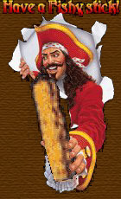
This fishy stick was popular in the official forum years before the release of Morrowind. The older members of the forum used to give this fishy stick to new members of the forum, by greeting that person and putting an image of a pirate holding a fishy stick. This was quite hilarious at that time and it became a unique behavior of the Elder Scrolls forum goers. This behavior, which was started by Captain Eldrad, disappeared shortly before the release of Morrowind. However, Bethsoft developers honored this forum goers behavior by putting a book titled "Capn's Guide to the Fishy Stick" in Morrowind, a book located in an ancient shipwreck in the Sheogorad Region. Here's a map made by Freddo. What are the contents of this book, you ask? Well, it just says that the book is supposed to be a definitive reference to fishy sticks throughout Tamriel, but unfortunately the pages are so smeared with fishy stick sauce that it's impossible to read any of them. It's very sad; otherwise you can find the book here in the library. And, now, please enjoy the fishy stick, esteemed reader.

Fat Lute
In the depths of the Sixth House base called Hassour, which can be found to the south of Balmora, an item of terrible power lies: the fat lute. Another one can be found with Marilia Saram in the cave Adanumuran near Balmora. Its ID, "misc_de_lute_01_phat", shows that this is probably a reference to the term "phat lewt", which is internet slang meaning powerful loot. "Phat lewt" is used especially in MMORPGS.
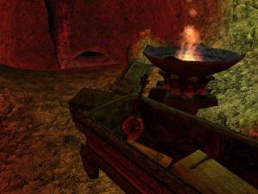

Funny Sound
In the Morrowind\Data Files\Sound\Fx directory there is a strange .wav file called "funny.wav", which cannot be heard anywhere in the game. Interestingly enough, if you use a sound program to reverse it, "Sam has no pit hair" can be heard. Heh... The developers never cease to amaze me. Anyway, thanks to Evoker for telling us about this file and thanks to The Z-Man for telling us to listen to it in reverse.
In case you want to listen to the unaltered file, here it is in .mp3 format. I've also included the reversed file.
funny.mp3
funnyreversed.mp3

Hidden Stash Near Thirsk
here's a hidden stash at the back of the mead hall Thirsk that contains the most deadliest stuff in all the Morrowind game and its addons: Ebony Arrows of Slaying. These things cast a Drain Health 5000 on anything that they hit, so nothing can survive them. Also, in the same stash there is also a note that can be found here.
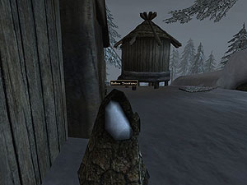

Huge Creatures
In the Grazelands, near the mountains just west of the Nerano Ancestral Tomb, monsters are set to spawn doubled in size. Very... Interesting. By the way, the Nerano Ancestral Tomb can be found west of Vos.
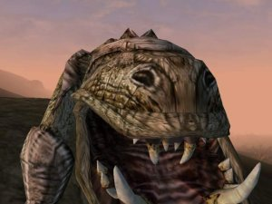
Say "cheese"!

Indiana Jones
In the Omalen Ancestral Tomb, which can be found north of Kogoruhn, is the skeleton of a world-renowned archaeologist who was crushed by a huge boulder when the cave he was in collapsed. Quite a sad tale, really. If you desire to read this archaeologist's journal, you can find it right here.
And, just so you know, if you one day stumble upon this archaeologist's body, you can't really recover his whip, gun or hat. So don't try.
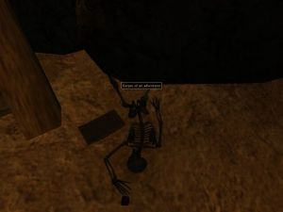 | 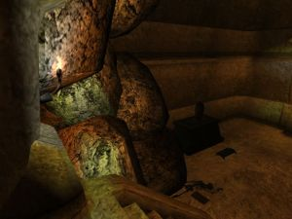
He looked much better alive. Don't you agree?
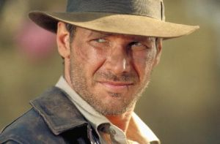

Joshur The Bard
If you've visited a lot of forts in Vvardenfell, you've most probably seen a lot of prisoners. Well, have you ever tried talking to them? Their dialogues aren't very funny or interesting, but I think that Joshur's, a Khajiit in Ebonheart, Buckmoth Fort, is worth recording. This is how he greets you:
"Joshur wrote a stupid poem and now Joshur is in bad trouble."
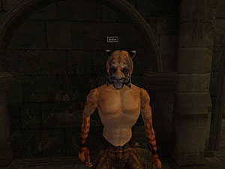
If you wish to know, Joshur is a bard. I can only imagine what that poem was about... Anyway, If you ask him about getting him out of there, he says the following:
"No, Joshur is Khajiit. Joshur just get caught again."
Ah, that's very interesting.

Kagmeowti
Once upon a time, probably sometime early in the production of Morrowind, there was a Kagouti. But there were no sounds for this poor Kagouti, so the developers decided to give it some temporary sounds, until they would be able to find appropriate sounds for the nice creature. So they gave the Kagouti the following sounds:
moan2.mp3
roar2.mp3
scrm2.mp3
All three files files can be found in Morrowind\Data Files\Sound\Cr\kgout.
From now on, we will look at Kagouti with different eyes.

Lustidrike
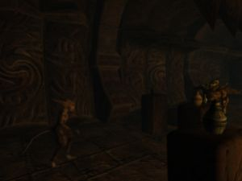
Lustidrike is a scamp that you can find in the Daedric ruin of Ald Daedroth, in the same chamber as the famous Ra'Gruzgob and he has some very memorable lines. This is how he greets you:
"Wanna drink, buddy? Got anything you want, so long as it's sujamma."
He certainly has a lot of things that he can offer you, now doesn't he? When you ask him about sujamma, this is what he says:
"Free drinks, f'lah. It's on the house. Only you gotta drink it here. Don't want you drinking and flying out there."
If you accept, this is what he says:
"Sure. Here ya go...."
If you refuse, this is what he says:
"Fine. You're the guest. Whatever you want."
If you accept, but have an intelligence lower than 30, this is what he says:
"Sorry, pal. You've had enough. Go get some exercise or something."
If you later talk to him, this is what he says:
"Back already? Well, go ahead, drink up. It's free."
If, when you talk to him later, your intelligence is below 30, this is what he says:
"Back again? I dunno, pal. You look like you've had plenty. Or maybe you ALWAYS look that way."

M'Aiq The Liar
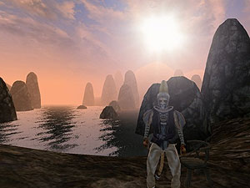
It was about time, if you ask me, to record the words of the famous Khajiit M'Aiq in the Imperial Library, but it's better late than never, isn't it? Of course, ever since a website dedicated to M'Aiq was made, almost everybody knows him, yet perhaps you can find out even more about him here. Or maybe I'm being a little bit hasty, as he's probably not that well-known as some would have us think, so for those of you who still don't know who M'Aiq is, I must tell you that he is a Khajiit living on a small island to the east of Dagon Fel, in the region of Vvardenfell known as Sheogorad. Oh, you're interested in his background, aren't you? Well, he doesn't talk much about that, but even though most people think he's a fisherman because he always has a fishing rod with him, I think he's one of the greatest loremasters in Tamriel. Yes, it's true that he has a different point of view of things compared to other loremasters, but that's just what makes him so special. As I was saying, he doesn't talk much about himself, but by studying his name I've managed to realize that he is a... Then again, maybe I should just quote Jobasha, another famous Khajiit living in Vvardenfell:
"'M' or 'Ma' means 'child' or 'apprentice' or, in the vernacular, 'virgin.' As an apprentice can be of any age, this leads to misunderstandings and jokes Jobasha cannot translate."
M'Aiq doesn't look like a child, and he's certainly way too knowledgeable to be an apprentice, so, seeing that the lives all alone on an island, that would make him a... What, do you expect me to tell you everything? Figure out what he is by yourself. Anyway, I've talked to M'Aiq at length and recorded his wise words, which I present to you here. This is how he saluted me:
"Greetings! M'Aiq knows many things. What is your interest? You seek knowledge. M'Aiq has much. Some of it verified by actual facts!"
When I asked him about becoming a lich, he said the following:
"You wish to become a lich? It's very easy, my friend. Simply find the heart of a lich, combine it with the tongue of a dragon, and cook it with the flesh of a well-ridden horse. This combination is certain to make you undead."
Next, I asked him about dragons. He had the following to say about them:
"Dragons? Oh, they're everywhere! You must fly very high to see most of them, though. The ones nearer the ground are very hard to see, being invisible."
Truly, this new information explains so many things! After that, I asked the wise M'Aiq about Emperor Crabs. What? You don't know what those are? Well, you've been in Ald-Ruhn, right? There was a huge shell-like building, yes? That, my friend, is what is left of an Emperor Crab. M'Aiq had the following to say about the Emperor Crabs:
"M'Aiq sees lots of them in the ocean. M'Aiq knows you'll see one too if you swim far enough."
Ah... So M'Aiq is also a swimmer! My admiration for the Khajiit never ceases to grow. Next, I asked M'Aiq about horses and he said the following:
"Horses.... Oh, M'Aiq loves horses! Especially with good cream sauce."
As much as I admire M'Aiq, he could not convince me to try eating horses. I asked him where I could find some mounts in Vvardenfell, and he had the following to say:
"You would wish to ride upon a beast? There is a way... Go to one of the many silt-strider ports and pay your fee! You wish one for personal use? Bah! Walk if you must; run if you are chased!"
I had expected M'Aiq to shed more light on the subject, but I appreciated his advice. Next, I asked him about moving corpses:
"Moving corpses? This sounds frightening to M'Aiq. The undead are nothing to be toyed with."
I could not agree more. I then asked M'Aiq what the word "multiplayer" means, since I had encountered it on my travels. He said the following:
"M'Aiq does not know this word. You wish others to help you in your quest? Coward! If you must, search for the Argonian Im-Leet, or perhaps the big Nord, Rolf the Uber. They will certainly wish to join you."
Ah, M'Aiq has heard of Rolf the Uber. Truly, he never ceases to surprise me. I wonder if Im-Leet is leet, though... Anyway, seeing as he knows so much, I asked M'Aiq about the mystery of the Dwarves, to which he replied the following:
"There is no mystery. M'Aiq knows all. The dwarves were here, and now they are not! They were very short folks... Or perhaps they were not. It all depends on your perspective. I'm sure they thought they were about the right height."
Well said, M'Aiq! If only those researchers would listen to your words, everybody would know what happened to the Dwarves! Now, when I was certain that M'Aiq was all-knowing, I asked him if he had heard about naked liches. He said the following:
"A horrible thing indeed. If you see one, let M'Aiq know. M'Aiq wants to make sure to look in the other direction."
By now, I thought of M'Aiq as my friend and mentor. And, as we were so close, I did not hesitate to ask him about nudity, to which he replied:
"Ahh... The beauty of the naked form. These Dunmer are rather prudish, are they not? Of course, there is an island you can reach filled with wonderful, naked, glistening bodies. It only appears when the moons are full, the rain falls, the seas run red, and it's M'Aiq's birthday."
He promised that he would take me to that fabled island one day, but I still have to wait... I then asked the Khajiit about rope climbing. He said the following:
"Climbing ropes that hang is too difficult. M'Aiq prefers to climb the ones that are tied horizontally."
Truly the words of a genius! As you should know my now, dear reader, my curiosity knows no bounds. And it is my curiosity that pushed me to ask M'Aiq about the Shrine of Boethiah, which I had heard had sunken beneath the sea. M'Aiq indulged me with the following answer:
"You seek the shrine that is no longer there? An interesting concept. Look to the seas to the West. There lies what was once the shrine. Take a deep breath and begin your search."
Hmm... So M'Aiq has even knowledge of the obscure! I hesitated to do so, but I eventually asked M'Aiq whether or not he had heard of a mysteriours talking mudcrab merchant. Here is what he said:
"M'aiq has heard of this. They've got all the money. Mudcrabs taking over everything. They already run Pelagiad."
It was getting rather late by now, but I managed to ask M'Aiq about weresharks before being driven away. Here is what he said:
"I have only met one, but he was afraid of the water."
And that is how my interview with M'Aiq ended. I truly hope that I can meet him again one day. Until then, however, there's always the talking mudcrab merchant...

Muffin
Directly north of Vivec City is the Gro-Bagrat Plantation, where an Orc named Gakkenfeld has the one muffin to rule them all, one muffin to find them, one muffin to bring them all and in the darkness bind them. Oh, sorry, I got a little carried away. What I was saying was that this Orc has the only muffin in the game and, if you love muffins, you should know that Gakkenfeld is quite safe to kill. Too bad the muffin has the same properties as bread.
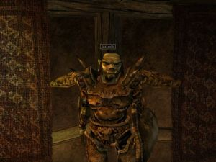

Naked Barbarians In Morrowind
During my travels through Morrowind I have encountered several naked barbarian Nords whose tales I decided to record only to realize that they were all very similar to each other. Yes, yes, their tales are mainly about the revenge that they would have against the witches who had robbed and/or cursed them because they had been way too friendly to them. Here I present you the three such tales that I have gathered, with a short description of the location of each Nord.
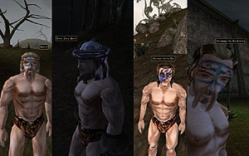
The first of the barbarians that I met was Botrir, who I found in the Grazelands, a short way west of the Dunmer stronghold of Indoranyon. This is how he greeted me:

"Hail, stranger! Have you seen a witch nearby? I'll tear out her heart and feed it to a nix hound!"
I asked him about the witch and this is what he said:
"Aye, I was escorting this... Woman, Iveri Llothri, to Tel Aruhn, and she seemed real friendly. Then for no reason, she turned on me! Put me under some spell, and by the time I realized what was happening, she had taken off with my gold, my armor, and my axe, Widowmaker! Damn her for even laying hands on the axe of my fathers! I'll tear her throat out and wear it as a belt! Come with me, stranger; help me find this devil and end her pitiful existence!"
It is, no doubt, an interesting tale. But an even more interesting tale is that of Hisin Deep-Raed, who I found on the road west of Ald-ruhn. He appeared to be paralyzed, but he could still speak, and this is how he greeted me:
"You! You will speak with me now, or you shall feel the bite of my axe! When this enchantment wears off, Hisin Deep-Raed will shed some blood!"
When I asked him about the enchantment, he said the following:
"Aye. A foul witch has given me some enchanted disease, leaving me rooted to this spot. She called it Witchwither. Foul temptress! I had been her escort; she was a big woman, friendly... You know. Then the damned witch ensorcelled me, leaving me at this spot, nearly naked, to display my shame to the world! Hisin Deep-Raed is not accustomed to being mocked, stranger! I shall paint the ground with her entrails!"
The similarities between the two stories that I have presented to you so far are obvious. But I would also like to present to you the tale of yet another naked barbarian Nord, Hlormar Wine-Sot, who I met on the road west of Caldera. He greeted me the following way:
"Hail and well met stranger! As ye can plainly see, I require some assistance if ye be kind enough to grant it. I need help finding the festering witch who has robbed me blind and left me for dead."
When I asked him about the festering witch, this is what he said:
"A witch she had to be. I was on my way to Caldera when I met her. She was a stranger here like myself, and our conversations lightened the burden of travel. She was quite friendly and, well, y'know, we set up camp together. But that night she revealed the witch inside. Cast a spell on me. I couldn't so much as blink! Stole everything, even my worn out clothes, but most importantly, she took my prized axe Cloudcleaver. Join with me, stranger! And let's find her and extract her entrails together!"
I accepted the Nord's offer and this is what he said:
"I knew you had the bloodlust in you, stranger! I believe she is still camped where I left her up to the northwest, though I could be wrong as the spell disoriented me a bit, it did. You know this area better than me -- lead the way! This witch shall rue the day she met Hlormar Wine-Sot!"
I asked the Nord about his axe and this is what he told me:
"Ah, me axe Cloudcleaver. A fine blade she is, though now I fear what that witch's touch will do to it. Me own father Balmir used it himself to slay the Terror of Wrothgar's Quagmire, he did. Now granted the Terror turned out to be a new born nix-hound eating the neighbor's marshmerrow, but me father found him and slew him nevertheless in as grand a fashion as I have ever borne witness to. I cannot wait to have the blade in my hands again, then I'll use it to take that witch's head clean off, I will."
Anyway, we set out to find this witch, which was somewhere in the surrounding area. We quickly found her. However, instead of attacking the young female Breton on sight, I decided to try to negotiate with her. This is what she said:
"Hello there stranger, I see you've already met my good friend Hlormar. My name is Sosia Caristiana, the healer. How can I be of assistance to the two of you?"
I told her what Hlormar had told me. She was amused by what she heard and I managed to find out the other side of the story:
"Ha! A right funny story that one is! The true story, Sinder, is that I took Hlormar on as a traveling companion for protection only for the road to Caldera. Along the way he was getting entirely too friendly for his own good, to the point where I actually had to cast a sleep spell on him. Just to teach him a lesson in manners, I stripped him and left him by the road. And to be sure he didn't come after me for retribution, I took that Cloudcleaver he's always fawning over as well."
When I asked her to give back Hlormar his axe, she said:
"Oh, I don't think he's ready to get it back quite yet. I can still see the rage burning in those tiny Nord eyes of his. However, if he meets me in three days at the Mage's Guild Hall in Caldera I will return everything I have of his, but not a minute sooner. Tell him that is Sosia's offer."
Of course, Hlormar did not agree with Sosia's offer, and he told me to pick sides. I decided not to get involved, so I fled. And I don't think I'll ever find out what happened to them... Anyway, a few months after that I came to Mournhold, the capital of Morrowind, where I encountered yet another naked barbarian Nord, whose name was Forstaag the Sweltering. Now, that's an interesting name, isn't it? Anyway, in the very moment that I saw him in a corner of the Plaza Brindisi Dorom, I was certain that he would tell me a very interesting tale about a witch which had robbed him of his clothes. I was wrong. Here's what he said:
"What're you looking at? No, I'm not paralyzed. And I've never even met a witch, much less been asked to escort one anywhere. Why am I naked? Because it's too damned hot here! You people think that every time you see a naked Nord barbarian, he's been tricked by some witch. So narrow minded. Now leave me alone."
Of course, I thought he was just too ashamed to admit the truth, so I continued to interrogate him. He then said the following:
"I told you I don't need any help. I'm just trying to cool off a bit. I've never even seen a witch! You people and your stereotypes..."
Later, after the attack on Mournhold by the fabricants, I talked to Forstaag again. Here's what he said:
"Look, I don't know what's going on in this place. Monsters bursting up from the ground, guards running around everywhere... This is lunacy. You'll notice I'm not blaming this on any witch. And it's still too hot around here."
And those, my friends, are all the naked barbarian Nords that I have encountered in the Imperial Province of Morrowind.

Orcish Khajiit
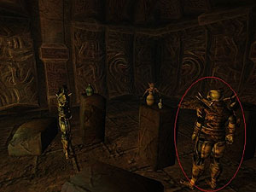
I've met many a Khajiit during my travels, and I've met many Orcs as well. But I vividly remember an orc who thought he was a Khajiit, the so-called Ra'Gruzgob, who I met in the Daedric ruin of Ald Daedroth. As you probably know, Orcs have a patronymic instead of a family name. Well, Ra'Gruzgob has a Khajiit name. I would like to quote the famous Jobasha here:
"'Ra' and 'Ri' show high status. 'Ri' is the highest status among the Khajiit, used by leaders of cities or tribes."
Ah, so Ra'Gruzgob is a very important Khajiit... Erm... Orc? I talked to him, and this is how he greeted me:
"Meow."
That surely explains a lot, doesn't it? I, myself, said "meow", to which Ra'Gruzgob replied thus:
"You like Ra'Gruzgob? Ra'Gruzgob likes you."
Well, I don't know what "meow" means, but Ra'Gruzgob seems to think that he knows. I then proceeded to ask Ra'Gruzgob about his background. He said the following:
"I'm Ra'Gruzgob, the Khajiit."
I asked Ra'Gruzgob whether or not he is an orc, and he said:
"Orc? Ra'Gruzgob is no Orc!"
After that, I asked Ra'Gruzgob if he is a Khajit, and this is what he replied:
"That's right. Ra'Gruzgob the Khajiit. How do you like my tail?"
I didn't know what to say and, seeing my puzzled expression, Ra'Gruzgob said the following:
"What? You never seen a Khajiit before?"
I then decided to say that his tail looks fine, and Ra'Gruzgob said the following:
"Hey, Ra'Gruzgob likes you. Maybe Ra'Gruzgob tells you a little secret."
When I asked him about his "little secret", Ra'Gruzgob asked me the following:
"Got any moon sugar for your pal Ra'Gruzgob?"
I had none, of course, since I'm not a drug addict, so I could not give Ra'Gruzgob any. He was a little upset and this is what he said:
"No moon sugar? No moon sugar for poor Ra'Gruzgob? Damn fleas..."
Fleas? What fleas? Hmm... Anyway, I saw that there was some moon sugar on a slab of stone, so I took it and gave it to Ra'Gruzgob. He was quite delighted and this is what he told me:
"Ra'Gruzgob knows something you'd like. Ra'Gruzgob put it under his pillow. For the sugar-fairy."
I searched under his pillow and found the artifact Gambolpuddy, but I had no need for it, so I left it where I had found it. When I asked Ra'Gruzgob about his secret again, he told me this:
"You find Ra'Gruzgob's little secret? Ra'Gruzgob knows you like it."
I asked Ra'Gruzgob about his name, and this is what he said:
"Ra'Gruzgob wants some MORE MOON SUGAR HERE!"
He then said:
"Hey, Lustidrike! Ra'Gruzgob wants some MORE MOON SUGAR HERE!"
You know Lustidrike, right? Anyway, after that he said the following:
"I said, 'Ra'Gruzgob wants some MORE MOON SUGAR HERE!'"
When I continued to ask him about his name, he said:
"Why you look at Ra'Gruzgob that way?"
What a poor, mad Orc. He made no sense at all. I have to admit that his words somewhat amused me, so I continued to ask him about his name, and his answer was this:
"Fifty drakes, same as in town."
Hmm... Strange. As far as I remember, moon sugar costs fifty drakes. Was he talking about that? Well, even though he was quite mad, I will always remember Ra'Gruzgob, the Orcish Khajiit...

Peke Utchoo
Mudan, an underwater Dwemer ruin that can be found to the south of Ebonheart, is the resting place of the famous Dragonbone Mail. It is also the resting place of a certain adventurer named Peke Utchoo, who can be found in Mudan's right tower. He accidentally poisoned himself and that is what led to his death. By the way, here are his last words.
Hmm... His name sounds somewhat familiar, does it not? Peke Utchoo sounds a lot like "Pikachu" when you say it out loud. Coincidence? Well, here's what Mr. Utchoo said in his note:
"If anyone shall ever find me, I hope I am able to bring them to laughter."
Of course, he is probably talking about the way he died. And the skeleton seems to be a little too large to be Pikachu's. Just compare the two.
 | 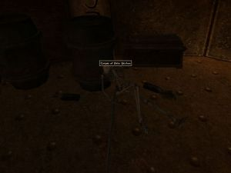

Pool of Forgetfulness
In Sharapli, which can be found a bit to the east of Ghostgate, there is an interesting pool called the Pool of Forgetfulness. When you activate it, it does nothing, so it is purposeless. Hmm... Perhaps the developers just forgot about it.
What was I saying? I seem to have forgotten...
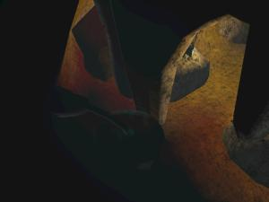

Pop Je
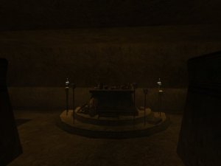
Ah, the famous Pop Je, whose skeleton can be found in the Senim Ancestral Tomb, which can be found east of Dagon Fel, in the region of Vvardenfell known as Sheogorad. Also, you can find the Ring of Phynaster on Pop Je, a ring about which you can learn more here. A forum legend says that Pop Je was an active member of the Elder Scrolls community who died while the developers were working on Morrowind, so they put his skeleton in the game as a tribute to him.
But it's time to put a stop to this legend. And what better way to do this than to quote developer Gary Noonan? Check this out:
"Have you ever happened across an NPC in Morrowind named Je Tee? And a woman with him named Kar Alber? Well, Je Tee was sorta kinda named after me, GT. Kar Alber was named after my THEN g/f. Pop Je would be Je Tee's father. My REAL LIFE father had died during Morrowind development, so in memory, I made an ingame tomb for him.
You will also notice a few other tombs in memory of various real life people. being a dev, we have certain advantages of adding easter eggs."
Je Tee and Kar Alber can be found in the Daedric ruin of Ald Daedroth.
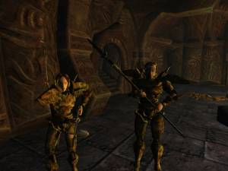
Je Tee And Kar Alber

Scourge
I'm sure you know Scourge, Bethesda developer Steve Meister's (AKA MrSmileyFaceDude) character. If memory serves me well, he used to role-play as Scourge on the Official Forums some while ago. Also, in Steve Meister's Industrial Light & Magic team diary on the official Elder Scrolls website, we can see a few screenshots of Scourge.
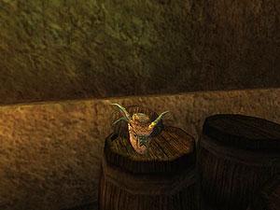
What does this have to with anything? Well, if you go to Vivec City, in the Lizard's Head cornerclub, you can find Scourge's head in the basement. Poor Scourge. Anyway, I wanted to know the story behind the head of Scourge, so I asked Steve Meister about Scourge.
Sinder Velvin: "Could you please tell me about Scourge the Argonian?"
Steve Meister: "Hehe. Well, he's just what I named my Argonian character that I used when working on & testing Morrowind."
Sinder Velvin: "Why did you put his head in a bar in Vivec?"
Steve Meister: "One day I was testing the game and exploring Vivec, and came across the Lizard's Head tavern. And there in the back was the Argonian head mounted on a plaque. And it was the same head I'd picked for Scourge. I'd already talked about Scourge on the forums and in other venues, so I had someone change the name of the mounted Argonian head to 'Scourge's Head'. So it was kind of an easter egg for the fans to find."
Very interesting.
Two of the official forum posts made by MrSmileyFaceDude have been recovered that mention Scourge.
"When I'm torture testing the magic system and other things I'm developing in the game, I actually play the real game. It's the only way to find the real problems. Anyway, I play as an Argonian Mage named "Scourge". Scourge LIVES for gold. It's all he cares about. He's a high level mage, at the top of his guild, and has a couple special spells that are his and his alone. One of these is called "Scourge's Wrath". Scourge's favorite activity is to go into a town, attain a high point where he can look down over the town and its denizens, and then cast the spell. A fireball shoots out, and at impact there's a huge explosion, and everyone within range is killed within a couple seconds. Scourge will repeat this until everyone's dead. Then, Scourge leaps down and calmly pilfers gold from the corpses.

[of course, I've set this all up in the editor. when I play Morrowind for real, my endeavor will be to start Scourge from scratch, build him up to be that high level mage and create Scourge's Wrath within the game. THEN he'll go around and kill everyone for their gold :-)]

Yeah, sounds like a kiddie game to me."

And a comment from Scourge himself about argonians.

"We Argonians are naturally resistant to the poisons and diseases that pervade the lush swamps from whence we came. And we can stay underwater much longer than less noble creatures. We are also quite skilled in the magick arts and make fine warriors. And we like gold, very much. It is shiny and makes us happy."

Talking Mudcrab Merchant
The talking mudcrab merchant is yet another famous easter egg in Morrowind. He, the talking Mudcrab merchant, is a... Well, he's a talking Mudcrab merchant living on an island just south-east of the Dwemer ruin of Mzahnch, east of Vivec City. He's always got ten thousand gold on him and he buys and sells everything at its base value. Basically, he's Creeper, except he's a Mudcrab, he has more gold than Creeper, he doesn't trade in as many kinds of items as Creeper does and he's in the middle of nowhere. But, if you want to meet him yourself, please be careful- he looks just like a normal Mudcrab, and he's labelled just like a normal Mudcrab. Here's how the talking Mudcrab merchant greets you:
"'How dry I am... How dry I am... Nobody knows... How dry I am....' SHAY! Hi. There. Lesh make a deal. I got... stuff. Lots. Here. See?"
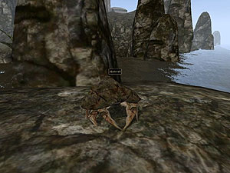
If you ask him about his background, this is what he says:
"Whaddaya think? Sheesh. I'm a mudcarb... Crab. Shure. A mudcrab. Thas me. Pretty sure. I LOOK like a mudcrab, right? Mush be. Thish IS me talking, right? So? I mush be... A talking mudcrab. And I sells stuff, right? So? I mush be a talking mudcrab merchant. Stands to reason, don't it?"
When you ask him about being a talking Mudcrab merchant, he says the following thing:
"Sure. Thash what I said? Did I stutter or shomethin? Talking. Mudcrab. Merchant. Read my lips. Ehr. Mouthparts? Read my mouthparts? Shomethin ain't right. But never mind. Jush one-a life's little myshteries. So. You gonna buy shomethin? Or sit here jawin' all day."
If you're curious why Creeper and the talking Mudcrab merchant buy and sell things at their base values, read the last paragraph over at Creeper.
And, by the way, do you need a map to this mudcrab? If so, it can be found here.

Tarhiel
If you travel to the north of Seyda Neen, you will eventually see a Bosmer falling from the sky, who will probably die from the fall. Besides his clothes, his gold and his weapon, you'll find two scrolls of Icarian Flight on his corpse, and on the ground you will find his journal. Apparently, his name is meant to resemble the word "tarheel", a reference to the basketball team called North Carolina Tarheels. You can find another reference to this basketball team here.
It is, apparently, possible to save Tarhiel's life, but if you try to talk to him afterwards, he'll just say the following:
"I don't want to talk about it."
That's what I call ungratefulness.
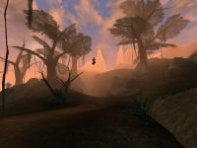
Is it a bird? Is it a plane? No, it's a Bosmer!
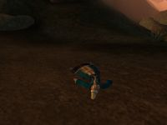
Another one bites the dust.

Testing Morrowind
During the course of making Morrowind, the developers made a lot of cells for testing purposes. Some of these cells can still be found in Morrowind's data file, but you cannot visit these cells without using the console. These cells are "Character Stuff Wonderland", "Clutter Warehouse - Everything Must Go!", "Draugr Test" (in BloodMoon), "ken's test hole", "Mark's Script Testing Cell" (in BloodMoon), "Mark's Vampire Test Cell", "Redoran Test", "Redoran Test 2" and "ToddTest". Thanks to ManaUser for reminding me to put "Mark's Vampire Test Cell" in here. If you want to visit one of these, just pop up the console and type the following:
player->coc "x"
Where x is the name of the cell you want to visit.
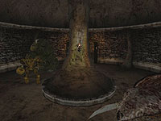 | 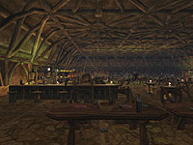 | 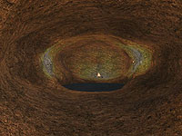
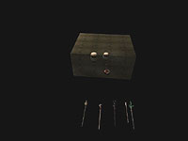 | 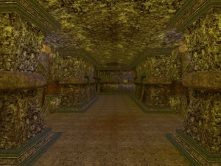 | 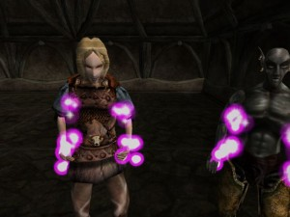
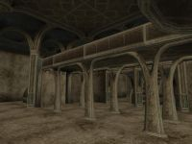 | 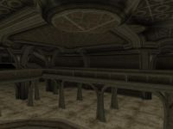 | 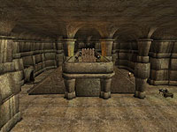
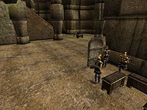 | 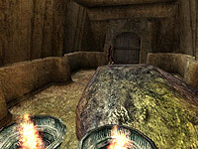
"Character Stuff Wonderland" was probably used to test creatures, weapons and containers.
"Clutter Warehouse - Everything Must Go!" is probably just an easter egg, and thus purposeless. It is possible, however, that it was used to test merchants and doors. Anyway, it is a very... Interesting place, as it has two strange NPCs in it: Lord Cluttermonkey, who is an Argonian in Daedric armor who has a mace called Clutterbane, and the Used Clutter Salesman, a Bosmer dressed in exquisite clothes who has a Daedric warhammer.
"Draugr Test" was probably used to test the creature known as Draugr.
I have nearly no ideea what "ken's test hole" was used for. Perhaps to see if certain meshes displayed correctly?
"Mark's Script Testing Cell" was used to test this quest.
"Mark's Vampire Test Cell" was used to test vampires.
"Redoran Test" and "Redoran Test 2" were used to test the Redoran arhitectural style.
"ToddTest" was used to test anything from female Khajiit to ordinators and from containers to scripts that make the player nearly invulnerable.

The Good, The Bad And The Ring
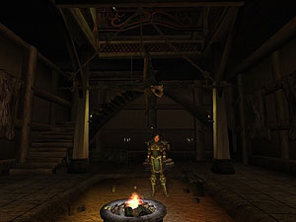
Cliff racers - do they need a presentation? No, they don't, since we all know and hate them, seeing that the Morrowind game was absolutely full of them. Tribunal was a welcome break from the cliff racers, but it was too short, and then it was back to Vvardenfell and its terrible cliff racers... Luckily for us, BloodMoon did not feature creatures from the old Morrowind, and everything on Solstheim was brand new. Or was it? There might not be any live cliff racers on Solstheim, but there is a stuffed one in the Skaal Village's great hall, hanging from the ceiling. Seeing as those infernal cliff racers are so common, you might have gotten so used to them as to not notice the one on Solstheim. Well, at least it was a dead one...
But there's one thing which is even harder to notice: the ring in the cliff racer's mouth. This item's ID is "bm_ring_view", it's "BlueDev's Ring of Viewing" in the game and it only shows up in the cliff racer's mouth if you've completed BloodMoon's main quest. Of course, what's it for? Well, you can see all of BloodMoon's pretty videos using this ring. And thanks to Geert and Evoker for telling us about this ring.

The Mystery of N'Gasta! Kvata! Kvakis!
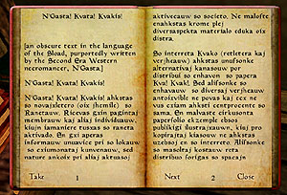
This book can be found almost everywhere in the Morrowind game. Even Telvanni Lord Aryon himself is working hard to translate this "necromantic book of the Sload race". Well, we now we have the translated text of this book in our library. But, before you read it, I must give you a warning: the way of the necromancers (er... devs) is hard to digest by the layman. So, brace yourself, as here is the translated text by Paul.

The Museum of the Imperial
You can't really say it's an easter egg, but there's one really funny thing in the Imperial museum in Tel Vos. But, before I say anything else, read this note that is on one of the walls of the museum:
"Welcome to the Imperial Museum and Library. Please feel free to peruse the exhibits at your leisure, but please do take care around the prisoner. He has been in a terrible mood since we had to cut down his rations after the escape attempt."
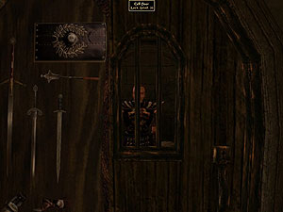
The prisoner he's talking about is an Imperial guard in a cell. Apparently, he's a very important exhibit...

The Natural
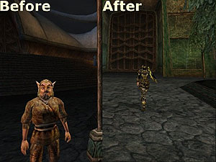

If you've ever played Tribunal, you've probably met Gaenor the Wood Elf, but for those of you who don't know him, he's a crazy Wood Elf who makes ridiculous demands and gets greedier and greedier the more that you help him. And he's the developers' answer to Fargoth haters. The quest involving him, called "The Natural", might not be an easter egg, but it sure is as funny as hell. To start this quest, you just have to visit the Temple Courtyard in Mournhold and talk to Gaenor, who should not be hard to find. Here's how he will greet you:
"Hello there, Dark Elf! Before you take another step, allow me to introduce myself. My name is Gaenor, and I'm... Well, I'm an entrepreneur of sorts. I was wondering if I could ask a small favor of you."
If you want to find out more about this "favor", he'll say the following:
"Glad you asked. As you may have noticed, I'm not looking my best at the moment. I'm a little, shall we say, down on my luck, which is NOT something I'm used to, let me tell you. At any rate, I'm looking for a little starting capital to get things rolling here in Mournhold - I've recently arrived myself, as well - and I thought you might be able to help me out. Think you could part with, say, fifty gold?"
Now things get really complicated. If you don't give him the fifty gold he asks for, he'll ask you again:
"Are you sure about that? I mean, to look at you, it's obvious that you're a Dark Elf of means. I imagine you wouldn't even know that the gold was gone. Think about it for another second or two. Think about how much it'd mean to me, about what a great help it would be."
If you still refuse to give him the fifty gold, he'll ask you once again, though less nicely this time:
"Ha ha. Quite the communication break-down we're having here, isn't it? I can see I'm just not getting through to you. Let me try this one last time, okay? It's ten gold. I know you have it. You won't miss it. I need it more than you do! Give it to me, okay?"
In fact, it's fifty gold, not ten gold as he says. Devs' mistake or Gaenor's "subtle persuasion techniques"? Either way, if you don't want to give him the gold, he'll get really upset and say the following:
"No?... NO? You don't say 'no' to me! NO ONE SAYS 'NO' TO GAENOR! Oh, don't you think I'll forget this. I'll remember you, Dark Elf, and I'll get you for it. I promise you that!"
If you don't have fifty gold, and yet you try to give it to him, he'll ask you for an ebony shortsword, but more about that later. If you give him the fifty gold, he'll ask you for more:
"Splendid! I really do appreciate it, and I must say, you're quite the generous soul. In fact, as long as we're talking, and getting along so well, do you think maybe you could spot me another hundred? I'm quite sure that I can pay you back in just a few days time. I've always had excellent luck when it comes to these sort of things. So, what do you say?"
If you don't give him the hundred gold he asks for, he'll ask you again:
"Heh. Umm, maybe I'm not being clear here. I'm trying to say that I'd REALLY appreciate it if you could just help me out a little bit. It's only a hundred gold. I'm sure you've got that much, and I'm sure you wouldn't even miss it. So come on. Really. Help me out!"
If you still refuse to give him the hundred gold, he'll ask you again, less nicely this time:
"Are you some kind of miser or something? I mean, seriously. A hundred gold, and you can't part with it? I've given away ten times as much in my day; a hundred gold is nothing! Now really, just hand it over already!"
If you refuse again, he'll get really upset and say the same thing that he would have said if you really didn't want to give him the fifty gold. If you don't have enough gold, he'll ask you for an ebony shortsword, but, as I've said, more about that later. If you give him the gold, he'll ask you for a thousand gold:
"You really are something, Sinder. I can see we're going to get along famously! Okay, I'll be up front with you. If I could just have another, oh, thousand gold or so, I can really make it here. I just know it. You've been so good to me, and it's clear that you've got the money... Just a little more help, that's all I ask for. You'll do it, right?"
If you don't want to give him a thousand gold, he'll ask again:
"Oh, come on. We've come this far with it. You've already proven yourself to be the generous type; why not go that extra step and really impress me? It's not like I'm asking for your first-born child here... Seriously. Think about it for a moment."
If you continue to refuse, he'll ask you again, less nicely this time:
"I AM speaking the same language, right? I mean, you understand what I'm saying? Well, then why can't you seem to understand that I need this money? Give it to me!"
If you refuse again, he'll get really upset and say the same thing that he would have said if you really didn't want to give him the fifty or hundred gold. If you don't have enough gold, he'll ask you for an ebony shortsword, but, as I've said already said two times before, I'll talk more about that later. If you give him the gold, he'll ask you for ten thousand gold:
"Wow! You have no idea what this means to me, Sinder. I've never held this much gold in my life! Well, heck. You've just got money to burn, don't you? I bet you could spare another 10000 gold, couldn't you? C'mon. I know you've got it. Let's have it!"
If you don't want to give him ten thousand gold, he'll ask again:
"What? Wait - let's try that again. I need ten thousand gold from you. You're going to give it to me, right?"
If you say no this time, he won't ask you again and will just get upset and say the very same thing that he would have said if you really didn't want to give him the fifty, hundred or thousand gold. If you don't have enough gold and yet try to give it to him, he won't ask you for an ebony shortsword- nope, he'll just get really upset and say the following thing:
"Oh, I see. You think this is all just some kind of joke. Offering me money you don't have. Well, I won't be laughed at. DO YOU HEAR ME? I won't stand for it! I'll get you, Dark Elf. I'll get you back for this, and then we'll see who's laughing!"
So, either way, he's really upset. If, however, you have enough gold and decide to give it to him, he'll say the following:
"I don't even know what to say. I'll never be able to truly pay you back for this. You've restored my faith in the world, Sinder. And boy, are you ever rich! I bet you've got a million gold. In fact, I bet you've got ten million! You must be the richest Dark Elf ever! You should give me a million, don't you think? Then we can both be millionaires!"
If you don't want to give a million, he won't even ask you again! He'll just get really upset, and say the very same thing that he would have said if you really didn't want to give him the fifty, hundred, thousand or ten thousand gold. And, if you even TRY to give him the gold (even if you, somehow, have it), he'll just get upset and say the following:
"Do you really think I'm that stupid? No one walks around with a million gold on them; that's ludicrous! I won't stand for this kind of patronizing! I WILL NOT BE MOCKED! You'll see, Sinder. You'll ALL see. I'll get you!"
So, whatever you say or do, he'll eventually get upset. Now, if you didn't have fifty gold back when he asked you for it, he'll ask you for an ebony shortsword:
"I love it that you want to help, but you don't have that much? Are you sure? Hmm. Well, perhaps we could work out some other sort of deal. Have you got maybe, I don't know, a nice ebony shortsword I could have? I mean, that'd be worth more than fifty gold, I know, but the value of that alone would solve all my problems. What do you say?"
If you gave him fifty gold, but if you didn't have a hundred left, he'll say the very same thing, but he'll replace "fifty" with "a hundred", so there's no point for me to write that again. If you didn't have a thousand gold when he asked you for it, he'll say the following:
"Umm, you don't seem to have that much. Well, I'm not particular. I'll just as easily take an ebony shortsword. Got one of those you can give me?"
If you choose not to give him an ebony shortsword in either one of those cases, he'll ask you again:
"I'm sorry, what? Oh, come on. Look at you! I'm sure you've got a whole stash of ebony weapons someplace! Probably have your own Ebony mine! I know you can spare it, so hand it over!"
If you refuse again, he'll just say the very same thing that he would have said if you really didn't want to give him the fifty, hundred, thousand, ten thousand or million gold. If you try to give him an ebony shortsword, but don't have one in your inventory, he'll say the following:
"What, you don't have one? Well, then don't offer me something you don't have! Sheesh. Some people. But listen. I don't need the sword all that badly, so it's okay. What I could REALLY use is a full suit of Daedric armor. I'm sure you've got an extra lying around someplace, right? Or you could dig one up for me? How about it, Sinder?"
If you have an ebony shortsword and give it to him, he'll say the following:
"Wow. What a great sword. I've held a few swords in my lifetime, but this... This is exquisite. Okay, clearly you've got some connections. How about getting me, your good friend, a full suit of Daedric armor? I'm sure there's enough floating around that you can find it, and get it for me. What do you say?"
So, if you try to give him an ebony shortsword, no matter if you have one or not, he'll ask you for a whole suit of Daedric armor. If you don't want to give it to him, he'll say the very same thing that he would have said if you really didn't want to give him the fifty gold, hundred gold, thousand gold, ten thousand gold, million gold or the ebony shortsword. If you tell him that you will try to get him a whole suit of Daedric Armor, he'll just get upset and say the following:
"You must REALLY think I'm dense, Dark Elf. Like YOU could put together a whole suit of Daedric Armor! I'm sure you just think you're so funny, don't you? Well, I'll teach you to laugh at me! You just wait, Sinder. I'll get you when you least expect it!!!"
So, whatever you say or do, Gaenor will eventually get upset. I suggest that you don't give him anything at all, since you will never be able to recover your stuff from him. Anyway, if you talk to Gaenor after he gets upset, he'll say the following:
"I won't forget you. Get out of my sight!"
If you try to attack him and are unable to kill him from the first hit, he'll teleport away after saying the following:
"OW! Vicious thug! I'll get you! I'll..... I'm getting out of here!"
If you get lucky and kill him from the first hit, the quest will end. Anyway, two days after you upset Gaenor, you will find him in the Temple Courtyard in a full suit of ebony armor. If you get too close to him, he will attack you, but not before saying the following:
"Well, well, well. Look who it is! My dear friend Sinder. Just my luck that you should stumble in here. Heh. Indeed, it seems my good fortune knows no bounds. Despite my mis-treatment at your hands, I've found riches, been able to influence just about anyone I talk to, and can you believe I've NEVER lost a fight? Never even gotten a scratch. Somehow I don't think I'll have a problem continuing that streak... and I owe you!"
After you kill him, the quest will end. Your reward? Well, you can loot Gaenor's body, but you will not be able to find the stuff you gave him (if any). Now, that was a funny quest.

Use The Force
In Star Wars Episode 5: The Empire Strikes Back, while on the planet Hoth, Luke Skywalker is captured by a monster and taken into its lair. When he wakes up several hours later, he finds out that his feet are stuck in the ceiling and that his lightsaber is below him, in the snow. He uses the force to bring the lightsaber to him and then uses the lightsaber to free himself.
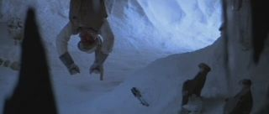
Anyway, the Bethesda developers decided to show us what would have happened if Luke wouldn't have been able to use the force to pull the lightsaber towards him. Just go to the cave Bjorn in Solshteim and you will eventually find a skeleton.
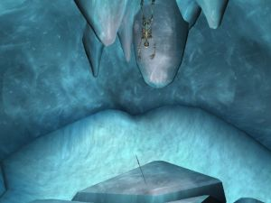
Very interesting, isn't it? By the way, in case you can't find Bjorn, you should know that it is to the southwest of the Skaal Village and to the southeast of Castle Karstaag.

Wormgod, Master of All Pipes
Developer Gary Noonan, AKA Wormgod, found a way to immortalize his nickname forever: he wrote it on the Dwemer pipes that can be found everywhere in Dwemer ruins. He wrote it in Dwemeris Script, though, so that's why not everyone knows about this.


